Code macros, as their name suggests, are normal Star functions that are invoked by the compiler on the text that the compiler is compiling. Code macros give the macro programmer almost the full power of Star to implement translation; in particular they can call other functions and use other types than quoted internally. However, code macros are a little more awkward to use than macro rules — there are some special restrictions on their form and what their scope is.
Code macros are embedded within a macro rule, in particular on the right hand side of a macro rule we can use a ## form — which, like its counterpart for validation rules, is a way of introducing nested scoping. For example, the top-level macro rule for processing triple graphs looks like:
# graph{?Graph} ==> list of [triples(Graph) ] ## {
#fun triples(A) is wrapComma(mapSemi(triple,A))
...
The environment part of the ## block consists of regular Star code with one or more equations prefixed by a # to mark them as code macros. In this case the function triples is such a code macro. It is invoked by name in the ‘bound’ part of the ## block:
list of [triples(Graph)]
Only those functions within the block that are marked by the prefix # may be mentioned directly within the enclosing macro rule (or within any macro rules also defined within the ## block). Code macros must have the type
(quoted)=>quoted
Other functions within the ## block may have any valid type — and this is where the great power of code macros comes from. In particular, whereas macro rules only ever ‘use’ quoted terms, code macros can use other types and can invoke arbitrary functions (of any type) in order to achieve their task.
In addition, where the evaluation of macro rules is somewhat complex — reflecting the potential for overlapping rules — the evaluation of code macros is identical to that of regular programs.
The triples code macro above calls two functions: mapSemi and wrapComma — neither of which are themselves code macros. The first applies the function triple to each term in the brace structure that is the source of the triple graph. The definition of mapSemi is:
fun mapSemi(F,A) is
leftFold(F,list of [],unwrapSemi(A,list of []))
where unwrapSemi unfolds the sequence of terms from a ;-based structure to a list. Notice that mapSemi is not itself a code macro: it is simply a regular Star function; a fact that is reflected in it’s type signature:
mapSemi:((quoted)=>quoted,quoted)=>list[quoted]
There are some restrictions — you may not invoke any Star functions defined in the same package as the code macro itself is; other than functions defined within the same ## block. You can, however, refer to functions that have been imported from other packages. (This is more difficult to say than to follow.)
The wrapComma function is a kind of inverse to unwrapSemi except that it takes a collection of terms and forms it into the structure needed for list literals. It’s definition is:
fun wrapComma(list of [El]) is <| ?El |>
| wrapComma(list of [El,..More]) is <| ?El , ?wrapComma(More) |>
The definition of wrapComma makes good use of Star’s meta-language: in constructing what will be a list literal we have to form it from the appropriate structures. This figure illustrates the AST structure of the contents of a list literal:
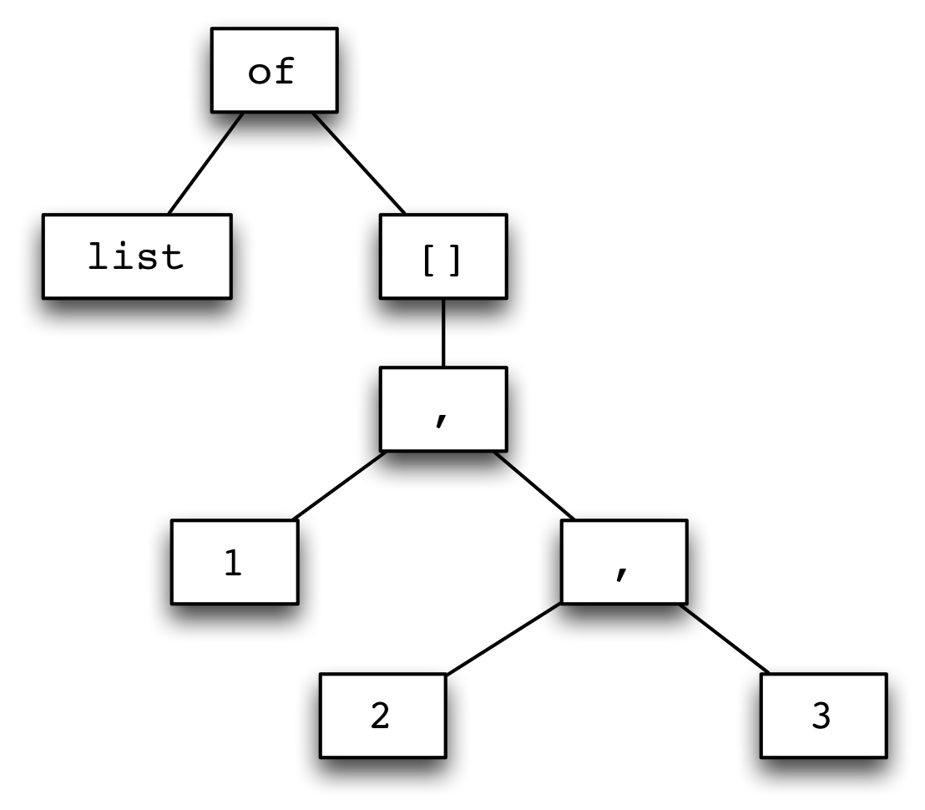
<$Scr_Ps::0>Graphical View of a list Expression
<!$Scr_Ps::0>It is useful that, in addition to being used to separate arguments in a list of arguments, the comma is also one of Star’s standard operators.
The most complex macros in our RDF macro package are those devoted to the processing of triples. The complexity arises from the inherent flexibility of the notation; in particular, any or all of the subject, predicate or object may be individual strings, named concepts or even lists of them.
We use an accumulator style of programming that is similar to what we saw earlier in [our Sieve of Eratosthenes][original-sieve]: the main functions all have a SoFar argument that represents the current accumulation.
For example, the function triple may result in any number of actual triples being generated; so it must generate a list of triples. It takes the form:
fun triple(SoFar,<| ?Sub ! ?VP |>) is
SoFar++
tripleJoin(trNounPhrase(list of [],Sub),
trVerbPhrase(list of [],VP))
Here, SoFar refers to the triples found so far. This is appended to the triples gotten by parsing the components of the triple.
The ++ function is a standard function to concatenate sequences.
The function trNounPhrase may find a list of nouns — i.e., a list of concepts — in the subject part of the triple. The trVerbPhrase performs a similar function for the predicate and it also invokes trNounPhrase to scan for objects:
fun trVerbPhrase(SoFar,<| [ ?VPs ] |>) is
SoFar++mapComma(trVerbPhrase,VPs)
| trVerbPhrase(SoFar,<| ?V $ ?O |>) is
SoFar++pairJoin(trVerb(list of [],V),
trNounPhrase(list of [],O))
trVerbPhrase has to ‘glue together’ an arbitrary collection of objects with the predicate; this is achieved with the pairJoin function:
fun pairJoin(L1,L2) is list of { (E1,E2) where E1 in L1 and E2 in L2 }
This function uses Star’s query expression notation to make the task simpler.
The triples in a triple graph are put together from the found subjects and predicate/object combinations — also using Star’s query notation:
fun tripleJoin(L1,L2) is
list of { <| n3Triple(?S,?V,?O) |> where
S in L1 and (V,O) in L2 }
The complete program (which we have not shown here) that implements the transformation of triple graphs is some 50 lines long. It is, in fact, part of Star’s standard library.

